

Model-Driven Conceptual Design

System Design and Management School

西村研究室

Task Reminder App

Task Reminder App

Author: Mattia

Revision:

|  |  |
| --- | --- |
|  |  |
|  | Date: October 24, 2022 |

# Model Introduction

**Model** **Specification>Documentation**

Author: Mattia.

Created: 24/10/22 4:15 PM.

Title: Task Reminder App.

Comment:

This is the model Task Reminder. The scope of this system is to give the user a way to automatically add everyday tasks to a calendar and to organize them in small tasks to complete throughout the week. The user should be able to see and edit tasks in both an easy way (visual way through suggestions of the system) and with more detail (through editing directly a file). A generic use case for this service has been generated showing minimum functions and the actors able to interact with this system. The system should be able to export the processed data to a Third Party Calendar to enhance the flexibility of the service. This model is of moderate complexity and detail.

# All Project Diagrams

## PoC Use Case

**Diagram Specification>Documentation**

**In:** Proof of Concepts.Functions.PoC Use Case

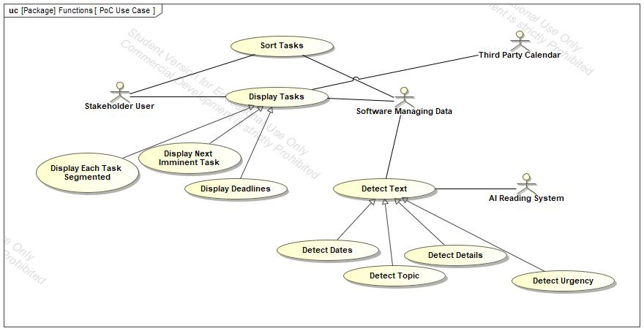

1. Diagram PoC Use Case

## PoC Blocks

**Diagram Specification>Documentation**

**In:** Proof of Concepts.Architectures.PoC Blocks

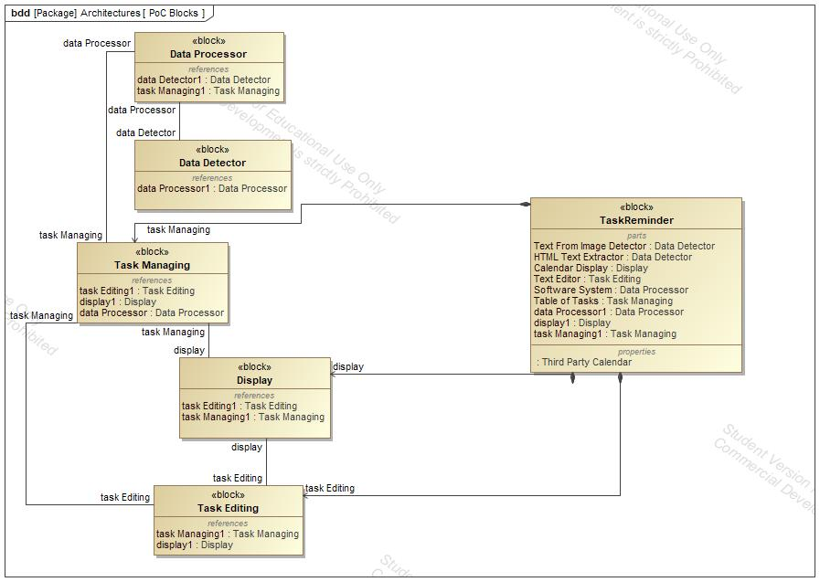

1. Diagram PoC Blocks

## TaskReminder

**Diagram Specification>Documentation**

**In:** Proof of Concepts.Architectures.TaskReminder.TaskReminder

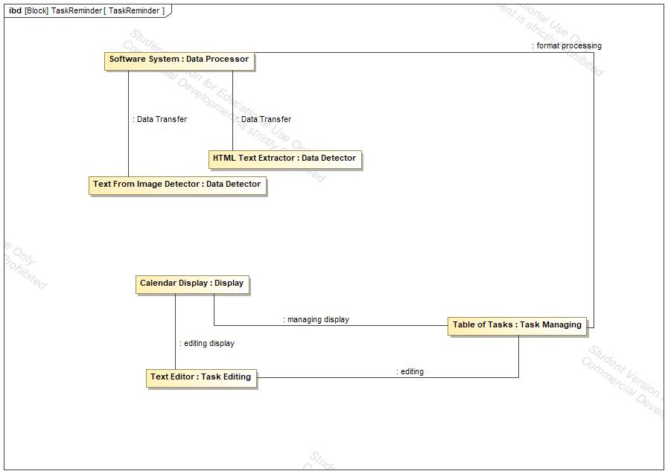

1. Diagram TaskReminder

## Proof of Concepts

**Diagram Specification>Documentation**

**In:** Proof of Concepts.Proof of Concepts

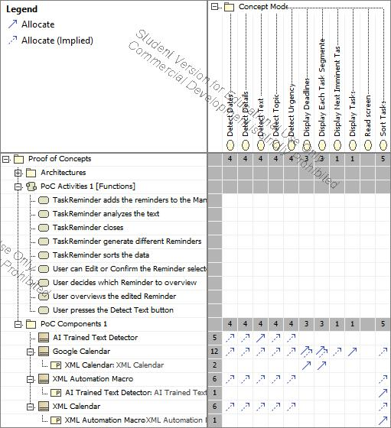

1. Diagram Proof of Concepts

## PoC Activities 1

**Diagram Specification>Documentation**

**In:** Proof of Concepts.Functions.PoC Activities 1.PoC Activities 1

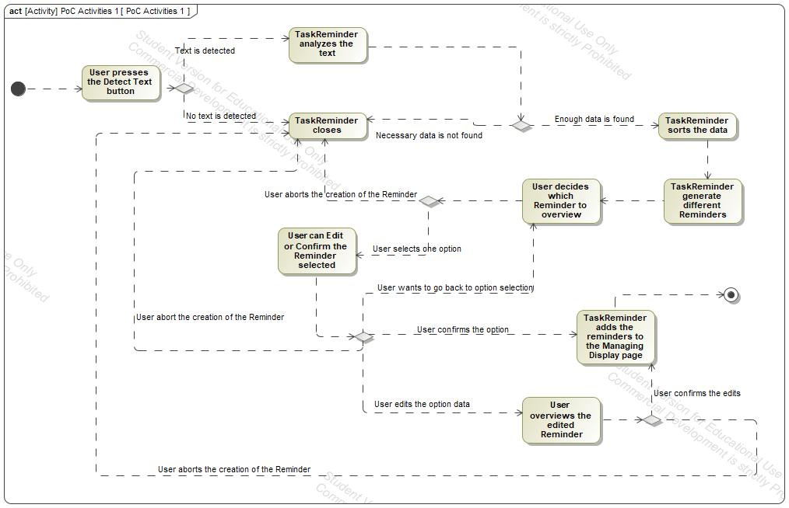

1. Diagram PoC Activities 1

## Concept Model

**Diagram Specification>Documentation**

**In:** Concept Model.Concept Model

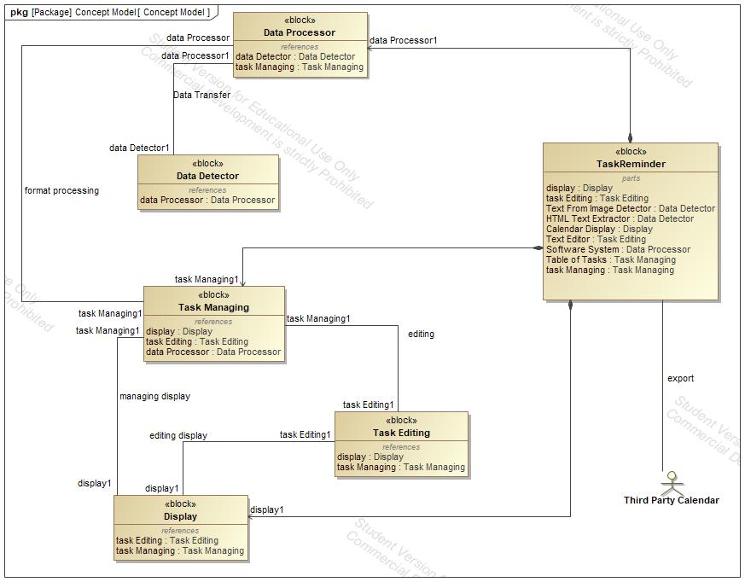

1. Diagram Concept Model

## PoC Model 1

**Diagram Specification>Documentation**

**In:** Proof of Concepts.PoC Model 1

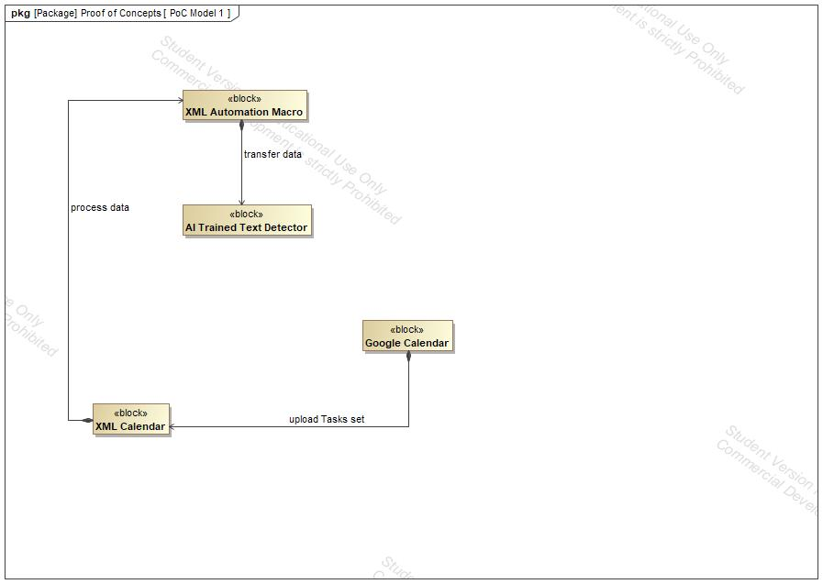

1. Diagram PoC Model 1

# Concept Use-Cases

|  |
| --- |
| **UseCase** |
| Detect Dates |
| Detect Details |
| Detect Text |
| Detect Topic |
| Detect Urgency |
| Display Deadlines |
| Display Each Task Segmented |
| Display Next Imminent Task |
| Display Tasks |
| Sort Tasks |

## Actor Summary

|  |  |
| --- | --- |
| **Primary Actor** | **Use Cases** |
| AI Reading System | * Detect Text |
| Software Managing Data | * Detect Text      * Display Tasks      * Sort Tasks |
| Stakeholder User | * Display Tasks      * Sort Tasks |
| Third Party Calendar | * Display Tasks |

## Use Case: PoC Use Case Diagram



## Detect Dates Use Case

|  |  |  |  |
| --- | --- | --- | --- |
| **Use Case Name** | Detect Dates | ID |  |
| **Complexity** | Average Complexity | | |
| **Description** | The system searches for dates. | | |
| **Actors** | See parent class for actor associations | | |
| **Goal** |  | | |
| **Assumption** | No assumption for this use case. | | |
| **Non Functional Requirements** | No non-functional requirement for this use case. | | |

|  |  |
| --- | --- |
| **Relations** | |
| **Association** | No direct association to this use case. Check the parent use case (see Generalization below.) |
| **Generalization** | * Detect Text UseCase |

## Detect Details Use Case

|  |  |  |  |
| --- | --- | --- | --- |
| **Use Case Name** | Detect Details | ID |  |
| **Complexity** | Average Complexity | | |
| **Description** | The system searches for additional information to add to the Reminder, that could be useful as a guideline to complete the Task. | | |
| **Actors** | See parent class for actor associations | | |
| **Goal** |  | | |
| **Assumption** | No assumption for this use case. | | |
| **Non Functional Requirements** | No non-functional requirement for this use case. | | |

|  |  |
| --- | --- |
| **Relations** | |
| **Association** | No direct association to this use case. Check the parent use case (see Generalization below.) |
| **Generalization** | * Detect Text UseCase |

## Detect Text Use Case

|  |  |  |  |
| --- | --- | --- | --- |
| **Use Case Name** | Detect Text | ID |  |
| **Complexity** | Average Complexity | | |
| **Description** | The AI Reading System detects the text on the screen. It searches for Dates, Topic, Urgency and additional Details. | | |
| **Actors** | * AI Reading System * Software Managing Data | | |
| **Goal** |  | | |
| **Assumption** | No assumption for this use case. | | |
| **Non Functional Requirements** | No non-functional requirement for this use case. | | |

|  |  |
| --- | --- |
| **Relations** | |
| **Association** | * AI Reading System Actor * Read screen UseCase * Software Managing Data Actor |
| **Generalization** |  |

## Detect Topic Use Case

|  |  |  |  |
| --- | --- | --- | --- |
| **Use Case Name** | Detect Topic | ID |  |
| **Complexity** | Average Complexity | | |
| **Description** | The reading system detects the topic of the text to set a name for the Reminder. | | |
| **Actors** | See parent class for actor associations | | |
| **Goal** |  | | |
| **Assumption** | No assumption for this use case. | | |
| **Non Functional Requirements** | No non-functional requirement for this use case. | | |

|  |  |
| --- | --- |
| **Relations** | |
| **Association** | No direct association to this use case. Check the parent use case (see Generalization below.) |
| **Generalization** | * Detect Text UseCase |

## Detect Urgency Use Case

|  |  |  |  |
| --- | --- | --- | --- |
| **Use Case Name** | Detect Urgency | ID |  |
| **Complexity** | Average Complexity | | |
| **Description** | The system searches for text related to the urgency of the Task. | | |
| **Actors** | See parent class for actor associations | | |
| **Goal** |  | | |
| **Assumption** | No assumption for this use case. | | |
| **Non Functional Requirements** | No non-functional requirement for this use case. | | |

|  |  |
| --- | --- |
| **Relations** | |
| **Association** | No direct association to this use case. Check the parent use case (see Generalization below.) |
| **Generalization** | * Detect Text UseCase |

## Display Deadlines Use Case

|  |  |  |  |
| --- | --- | --- | --- |
| **Use Case Name** | Display Deadlines | ID |  |
| **Complexity** | Average Complexity | | |
| **Description** |  | | |
| **Actors** | See parent class for actor associations | | |
| **Goal** |  | | |
| **Assumption** | No assumption for this use case. | | |
| **Non Functional Requirements** | No non-functional requirement for this use case. | | |

|  |  |
| --- | --- |
| **Relations** | |
| **Association** | No direct association to this use case. Check the parent use case (see Generalization below.) |
| **Generalization** | * Display Tasks UseCase |

## Display Each Task Segmented Use Case

|  |  |  |  |
| --- | --- | --- | --- |
| **Use Case Name** | Display Each Task Segmented | ID |  |
| **Complexity** | Average Complexity | | |
| **Description** |  | | |
| **Actors** | See parent class for actor associations | | |
| **Goal** |  | | |
| **Assumption** | No assumption for this use case. | | |
| **Non Functional Requirements** | No non-functional requirement for this use case. | | |

|  |  |
| --- | --- |
| **Relations** | |
| **Association** | No direct association to this use case. Check the parent use case (see Generalization below.) |
| **Generalization** | * Display Tasks UseCase |

## Display Next Imminent Task Use Case

|  |  |  |  |
| --- | --- | --- | --- |
| **Use Case Name** | Display Next Imminent Task | ID |  |
| **Complexity** | Average Complexity | | |
| **Description** |  | | |
| **Actors** | See parent class for actor associations | | |
| **Goal** |  | | |
| **Assumption** | No assumption for this use case. | | |
| **Non Functional Requirements** | No non-functional requirement for this use case. | | |

|  |  |
| --- | --- |
| **Relations** | |
| **Association** | No direct association to this use case. Check the parent use case (see Generalization below.) |
| **Generalization** | * Display Tasks UseCase |

## Display Tasks Use Case

|  |  |  |  |
| --- | --- | --- | --- |
| **Use Case Name** | Display Tasks | ID |  |
| **Complexity** | Average Complexity | | |
| **Description** | The Display Tasks page allows the user to overview all the added Reminders. The User can edit every Task added. The Display Tasks page is similar to a calendar. | | |
| **Actors** | * Software Managing Data * Stakeholder User * Third Party Calendar | | |
| **Goal** |  | | |
| **Assumption** | No assumption for this use case. | | |
| **Non Functional Requirements** | No non-functional requirement for this use case. | | |

|  |  |
| --- | --- |
| **Relations** | |
| **Association** | * Software Managing Data Actor * Stakeholder User Actor * Third Party Calendar Actor |
| **Generalization** |  |

## Sort Tasks Use Case

|  |  |  |  |
| --- | --- | --- | --- |
| **Use Case Name** | Sort Tasks | ID |  |
| **Complexity** | Average Complexity | | |
| **Description** | The Managing Data Software will manage the Tasks detected and sort them based on Urgency and Deadlines from Dates. | | |
| **Actors** | * Software Managing Data * Stakeholder User | | |
| **Goal** |  | | |
| **Assumption** | No assumption for this use case. | | |
| **Non Functional Requirements** | No non-functional requirement for this use case. | | |

|  |  |
| --- | --- |
| **Relations** | |
| **Association** | * Software Managing Data Actor * Stakeholder User Actor |
| **Generalization** |  |